**CS590BD**

**Big Data Analytics and Apps**

**FourthIncrement**

**Team:** Tunuguntla,Jeevana

Bathina, L V Sandeep

Marikanti, Goutham

Beeravalli, Ramakrishna Reddy

**Project goal and Objectives**

* **Motivation**: Gaming is the new face of entertainment. Upon learning that this form of entertainment also adds to the development of knowledge and intelligence of end user, we have chosen this work on this project. On an elaborated view, analysis of scores yielded from the game would be useful in assessing the intelligence level of individuals.
* **Significance**: Using generated data from game application we do analyze Data, based on analysis we can prepare a statistics of the user in his/her desired field. This type of analysis not only helps a particular user but also help many organizations,health organization and educational institution to asses a student or employee field of interest and to determine their capability.
* **Objectives:**our main goal in this project is to collect the data(i.e.) text file from an android device,this file mainly contains pattern in which a user is playing. Then we need to push this file to the hadoop file system and using an algorithm we analyze this data to generate report and also we willprovide recommendations to user to improvise them in their field of interest.
* **System features:**

**OS:** windows/linux

**Ram:** 4 GB or above

Android device version: At least 4.3

**IDE**: Eclipse ADT(to run android application) , eclipse kelper/juno(to run java application)

**Devices:** Sensor tags, android mobile having Bluetooth above 4.2.

**Activity Recognition scenario and data collection**

* **Devices/ Sensors**: CC2541 Sensor Tag  Development Kit, Computer with a minimum of i7 processor and 4gb Ram
* **Data Collection**: Data that would be generated from the game is in .txt file format and it is collected and stored in tables which we have created in HBASE.
* **Motion/activity Model**:

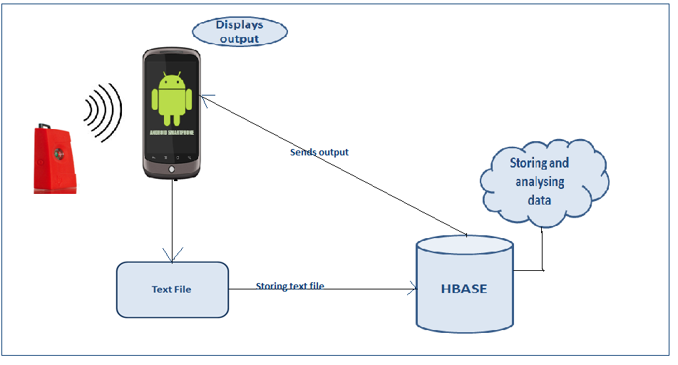

* **Analytical tasks**: The data shall be assessed for adaptive level information, and the performance of the gamer would be analysed based on the score he/she scores.
* **Design of mobile client :**

**Features**: android device version-4.4.2

**Styles andGUI:**

**Game Description**

**2048Game**

It is a single player puzzle game, which requires the user to slide the number titles on a square 4*4 grid, and upon combining them a tile would be created which has a number 2048.

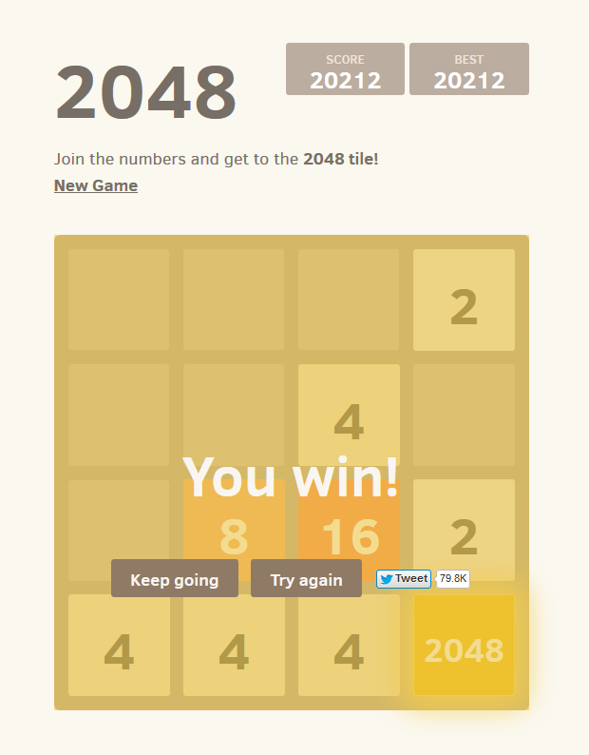

1. In order to develop the project, we got the open source for the 2048 game from the internet. Here, we will make some changes in the game source code according to our project interest.

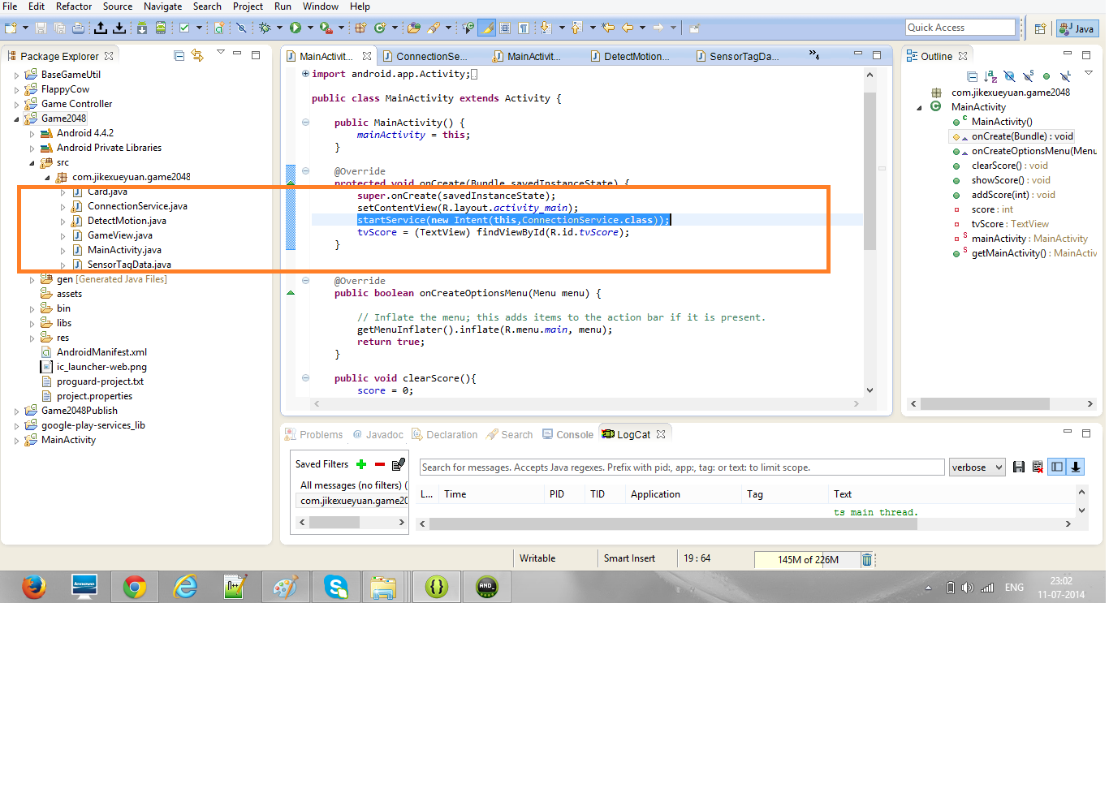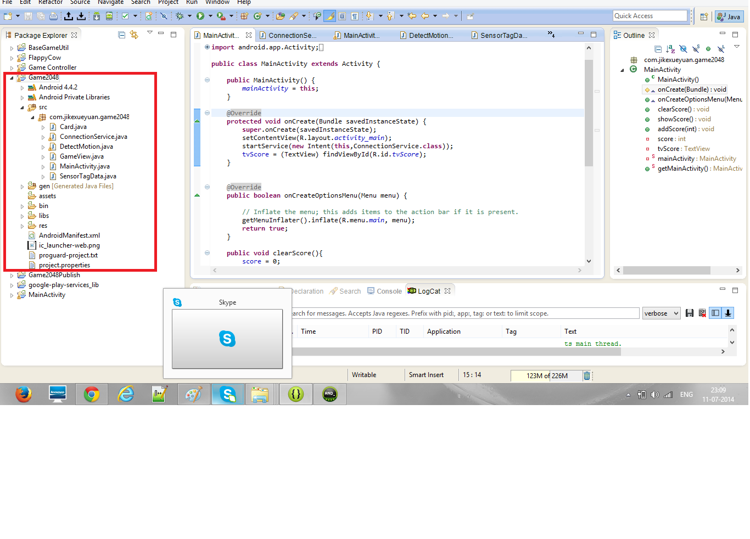

Gam

GAME

GTame

1. So here upon sliding the number tiles, there would a tile which shows up the sum of values being slide. The Game demonstration shows that when the sensor is moved towards right the tile values slides towards right and when slide towards left, the values sums up towards left and same in case of up and down. So based on that we will retrieve the report and analyze them accordingly.

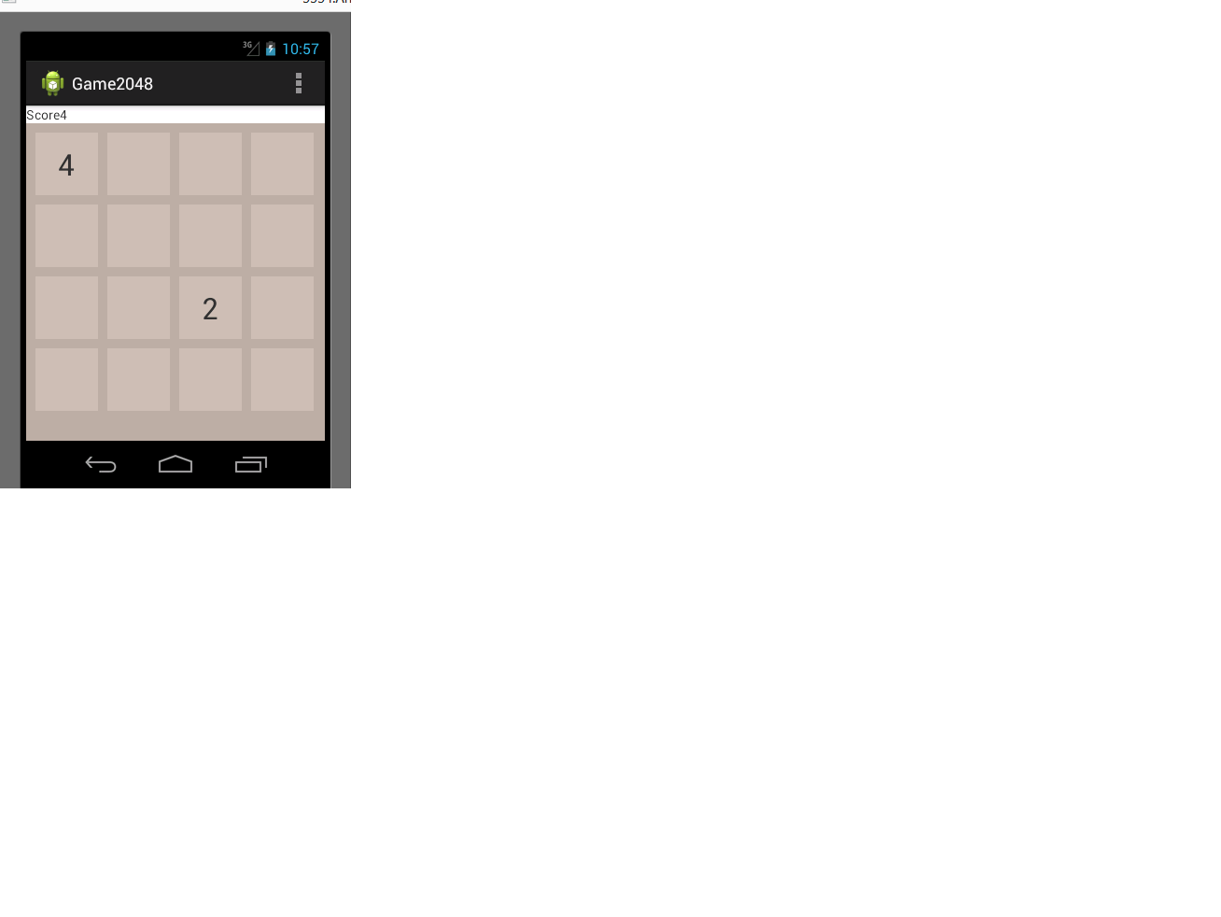

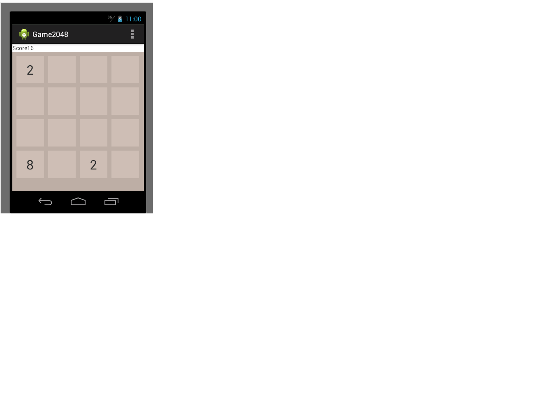

1. The analyzed part here is kept in the HBASE system tables in the form of rows and columns

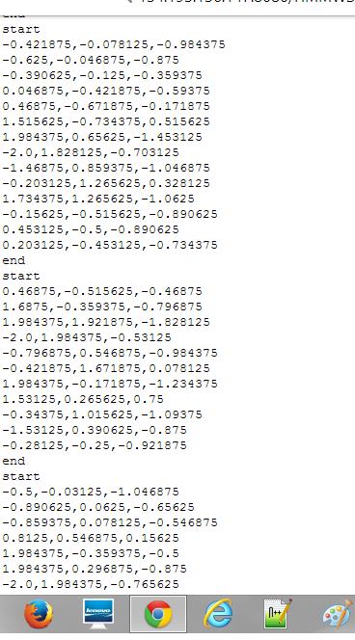

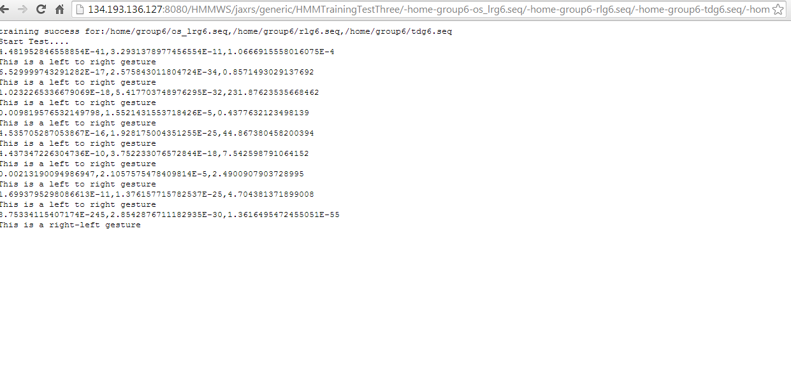

**Technologies**:JAVA, HBASE, Android

**Algorithms:**

**Data Filtering (Specify your approach/algorithm):**

In the filtering part, the data collected from the game is filtered by specifying start and end positions for the gesture. The similar way is followed for remaining gesture actions. The data collected is extracted based on K-means clustering Algorithm.

**Evaluation: Motion/Activity Recognition:**

The machine learning algorithm we are going to use is by HMM Model. Here the probabilities are calculated and based on that the correct gesture is determined.

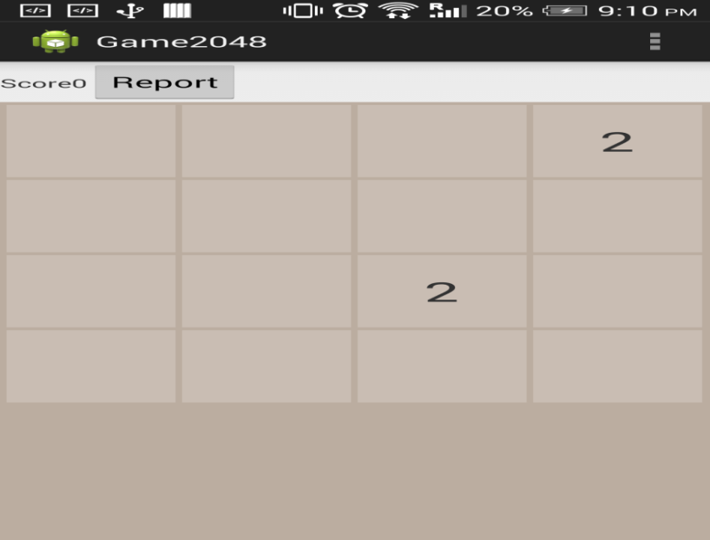

On clicking the above ‘Report’ button, the following screen will get displayed.

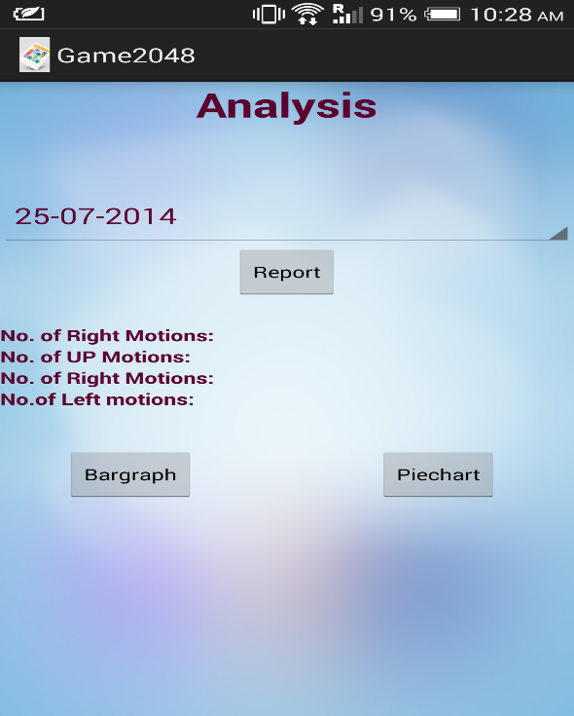

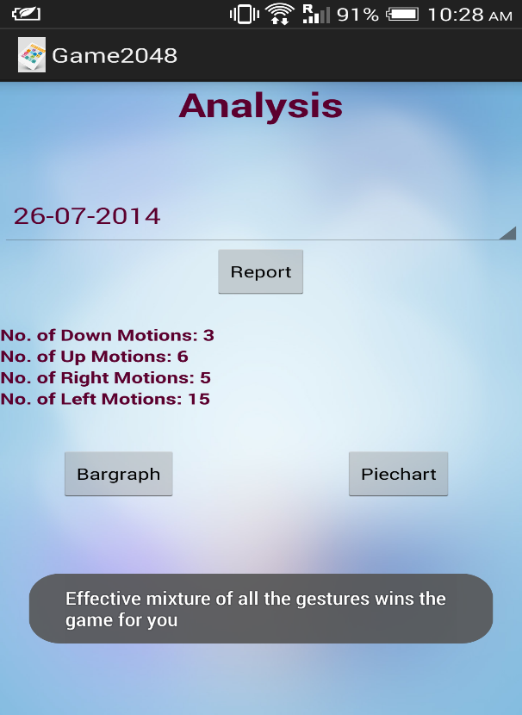

* **Graphical Report (Bar Graph, Pie Chart) :**

When the user selects a particular date and clicks on “Bar Graph button”, the corresponding day’s graph will be displayed with X-axis plotting the dates and Y- axis plotting number of motions corresponding to the gestures the user performs using the sensor tag.

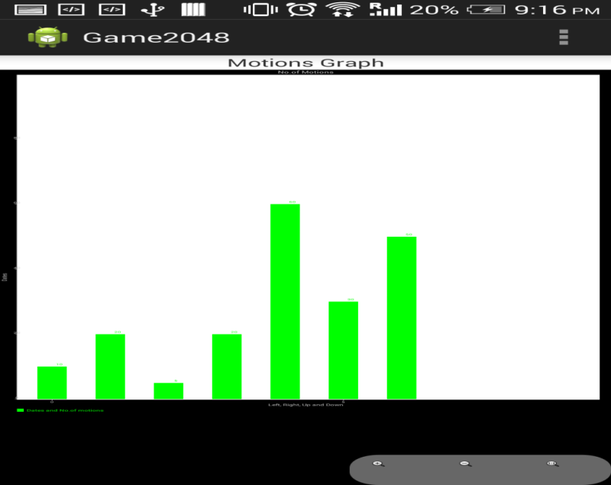

Similarly when the user selects a particular date in a particular time zone and clicks on the ‘Pie Chart’ button, a pie chart displaying the percentages of each of the four gestures as below:

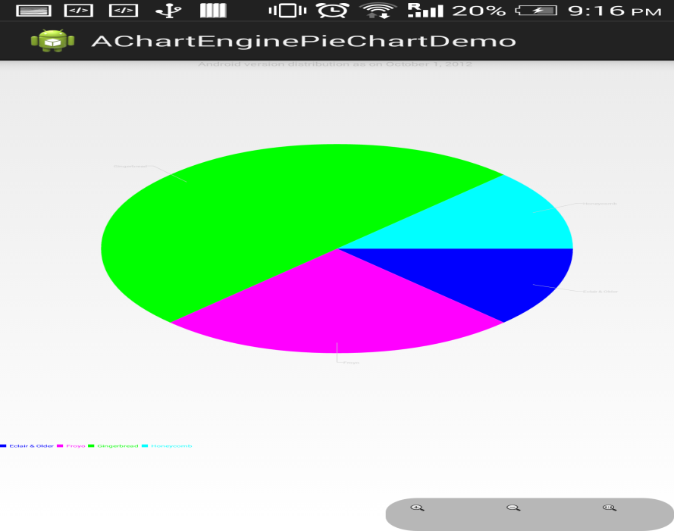

**Number of Users:**

Any number of users can play this game.

**Types of Motions/Activities:**

**Motions:->** Left, right ,up ,down ,punch

Number of gestures :- 5

**Data Preparation**



**Accuracy:**

50-60%

**Limitations**

* Capturing correct gesture became a challenging task.
* We took much care to obtain correct gesture because we need to hold sensor tag in only one direction while training.
* We have trained our application for 5 gestures.
* For each gesture we have generated 10-15 vector sets to train our application, it became a risky task to generate those many gestures for a single gesture. We took nearly 10-15 attempts to generate correct gesture.
* But we could reach 50-60% accuracy.

**Project Video**

**https://www.youtube.com/watch?v=uOh7_guqZis**

**Project Planning with Scrumdo:**

https://www.scrumdo.com/organization/cs590bd/dashboard

**Related work :**

<http://www.mel.nist.gov/msidlibrary/doc/serious_games02.pdf>

<http://newsroom.ucla.edu/releases/is-technology-producing-a-decline-79127>

<https://github.com/gabrielecirulli/2048>

<https://github.com/lanus1401/2048/tree/master/game2048/src/com/lanus/game2048>

.<http://www.lcc.uma.es/~ccottap/papers/lara13review.pdf>

* **Bibliography**

<http://www.edureka.in/>

<http://developer.android.com/training/basics/actionbar/index.html>

<http://efytimes.com/e1/fullnews.asp?edid=134678>